After getting the errors for all the all the points, from different models, we can draw it’s pdf and cdf to find which model is better.

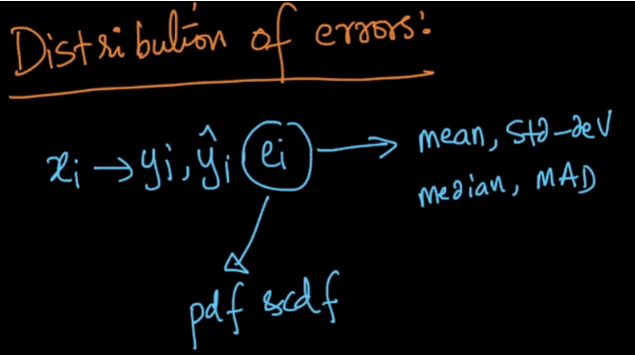

Let’s say we draw the pdf and cdf for errors as given below.

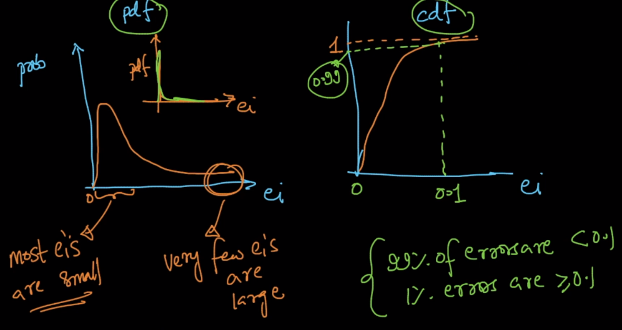

Let’s say we’ve two models M1 and M2 and cdf for errors obtained are plotted together, then cdf of whichever model is on the top is termed as the best model, below image justifies it.

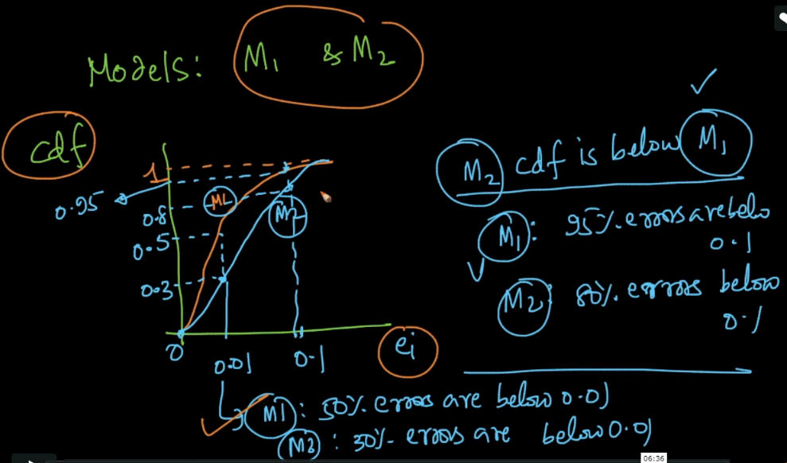

<https://medium.com/usf-msds/choosing-the-right-metric-for-machine-learning-models-part-1-a99d7d7414e4>